**Requirement 1: Data Loading –**

Loading of dataset

Step1: Create a database and tables

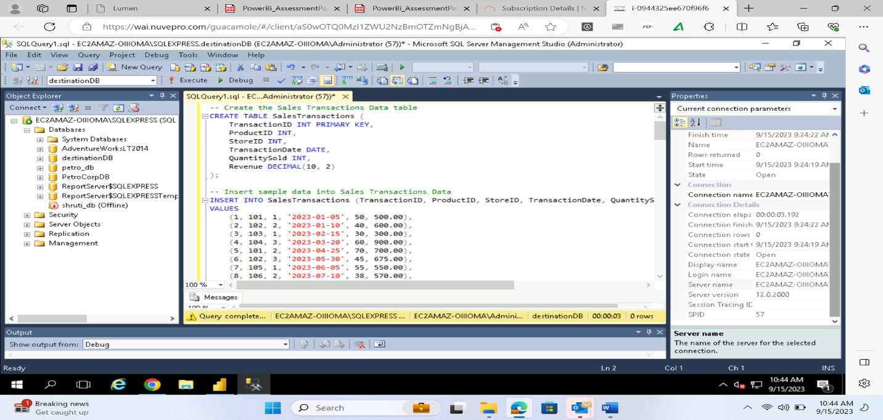

Tables inserted.

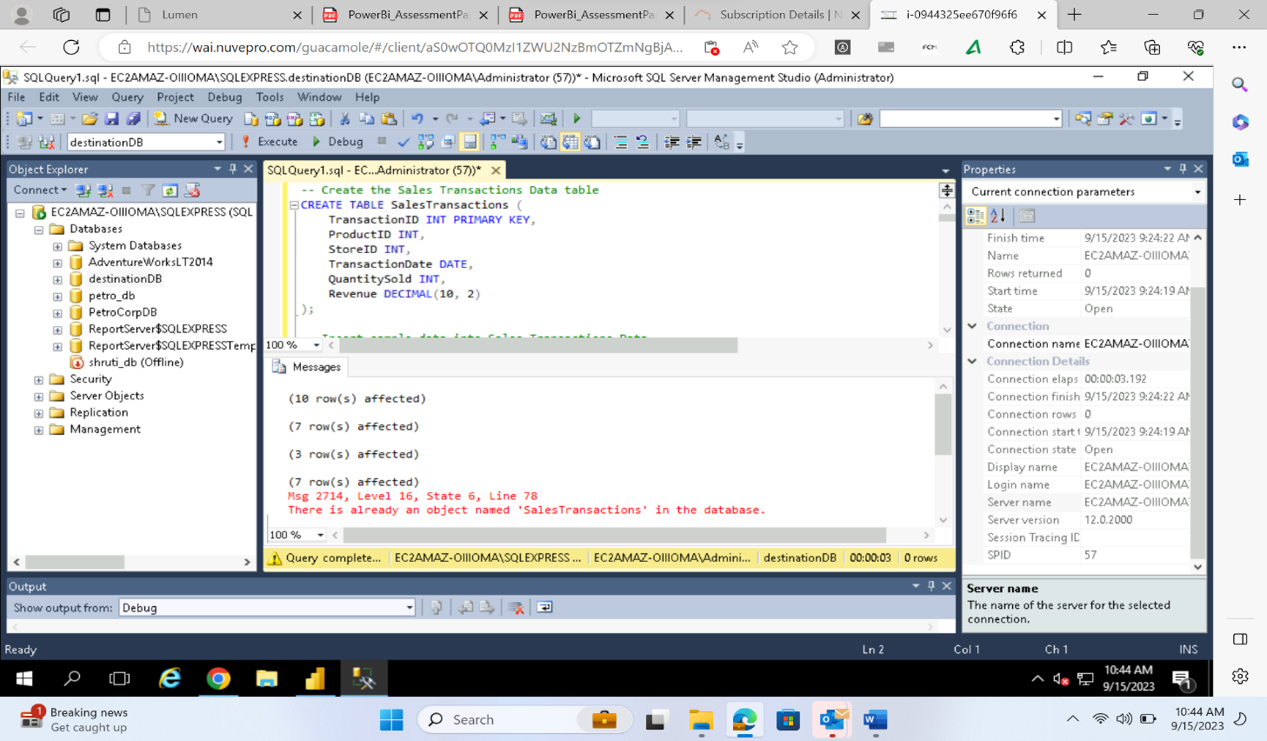

Step-2 Go to get data then SQL server

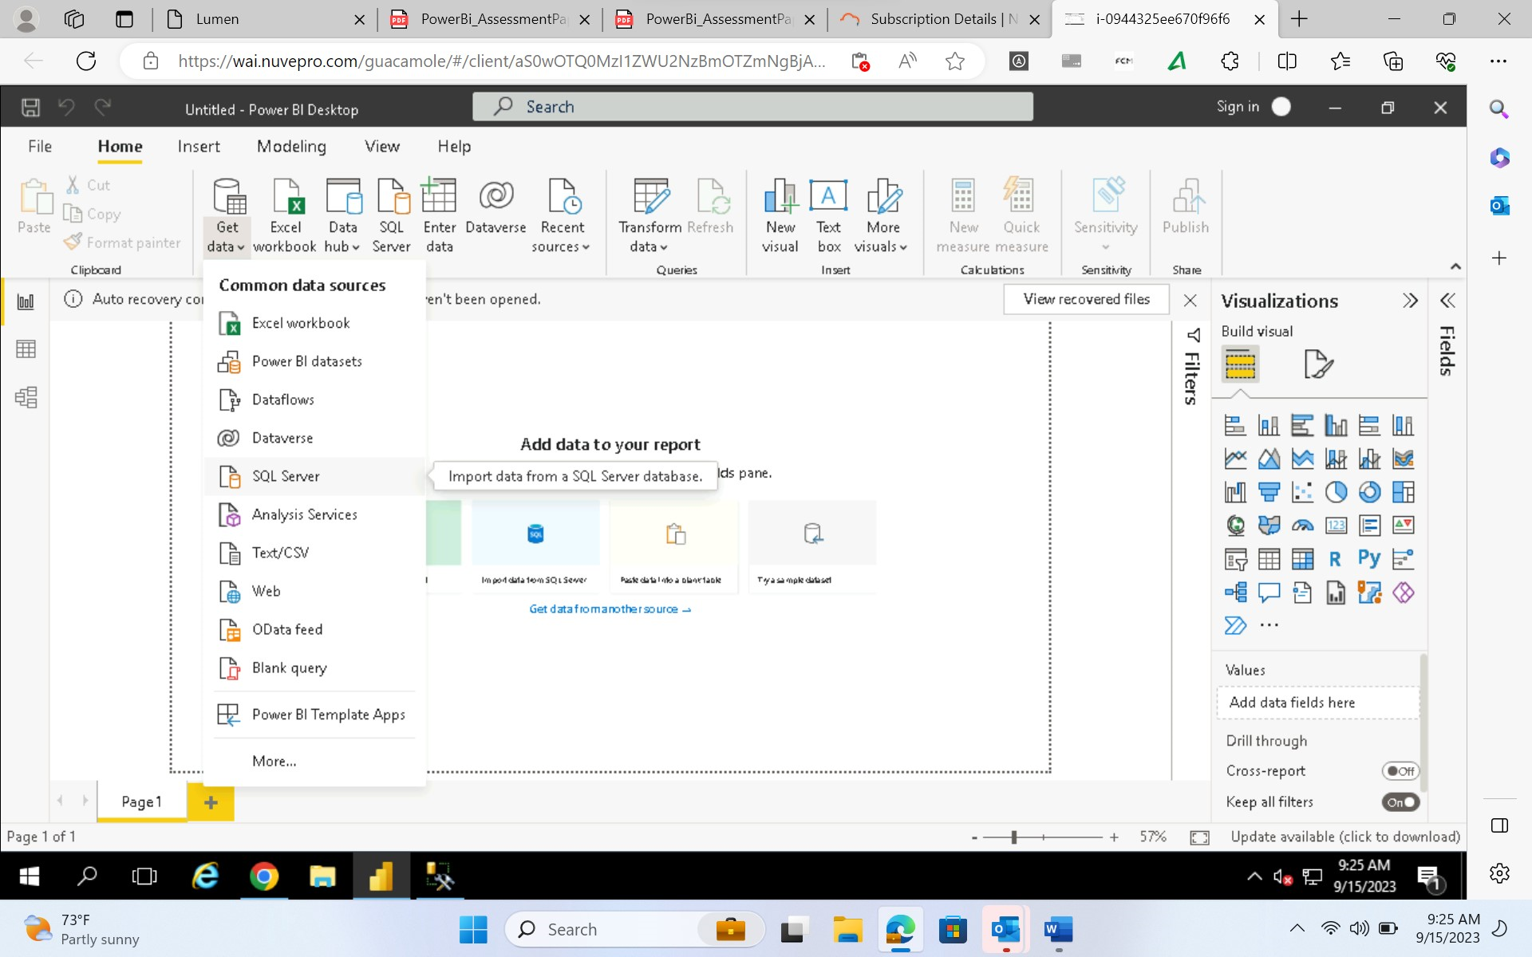

Step3: Select all the tables once they get loaded

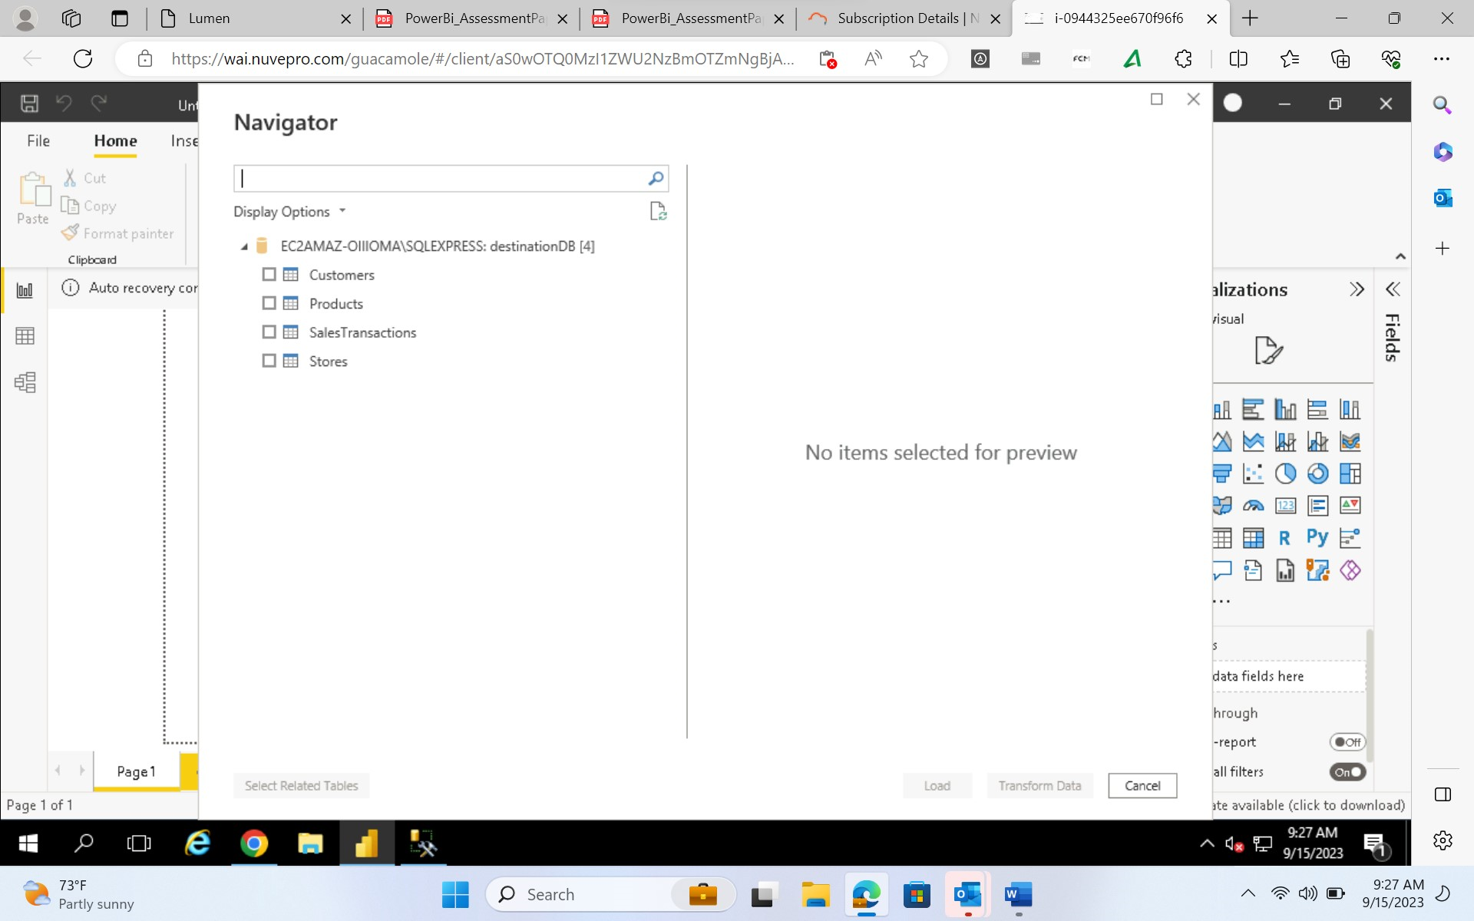

Step4: click on load and your dataset will get loaded

All the loaded tables can be seen on right hand side

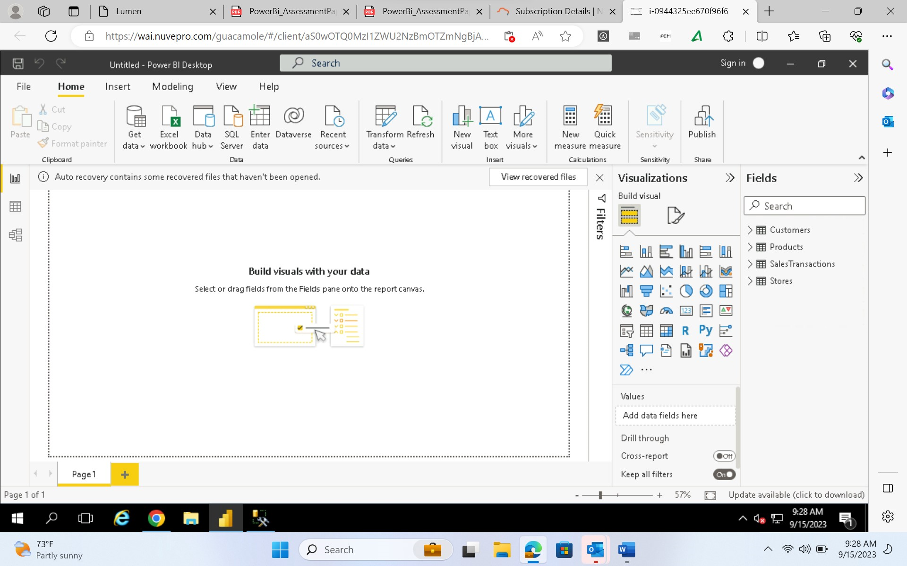

**Requirement 2: Data Transformation –**

Merge the data.

Go to the transform option, transform data , combine and then merge option then merge the tables

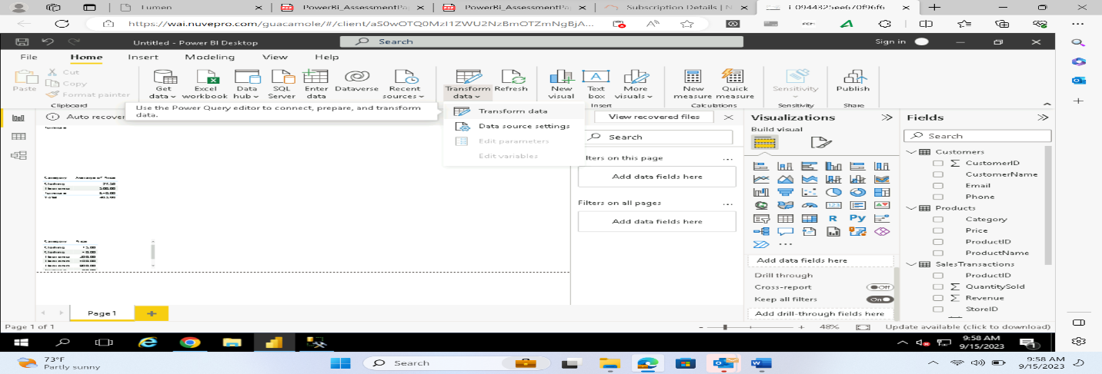

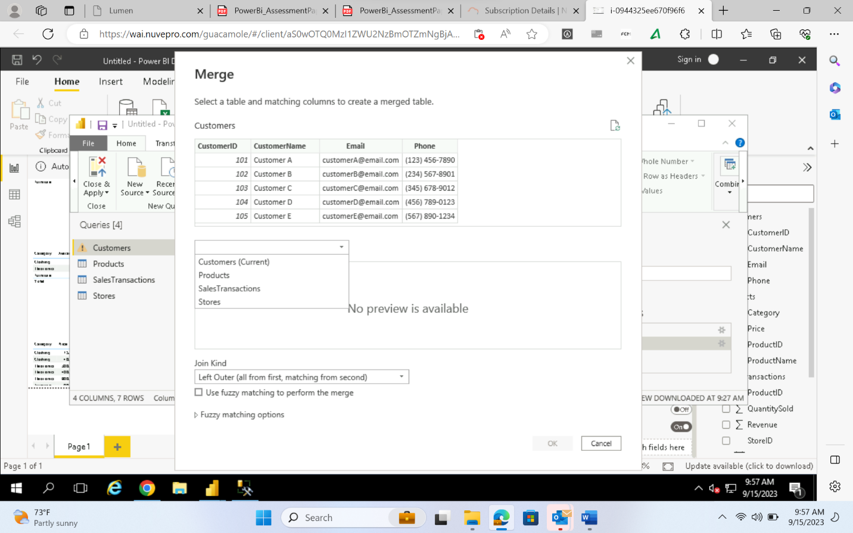

VISUALIZATION FILTERS

Filter the data ---:

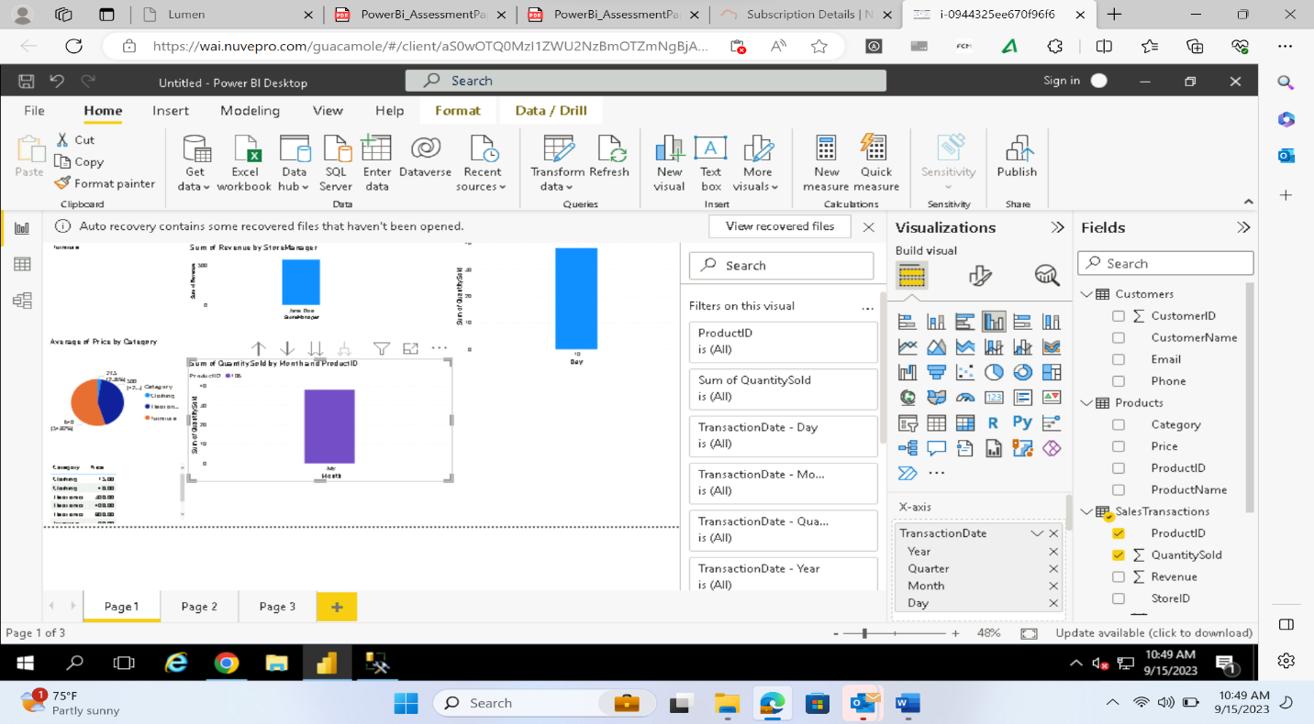

Clean the Data: Data cleaning can be done by removing null values from the tables, replacing column values with sum, average, minimum and maximum depending upon the data. As no null values are present so no data cleaning is required.

**Requirement 3: Data Modelling –**

One to Many relationship exists between products and Sales Transactions

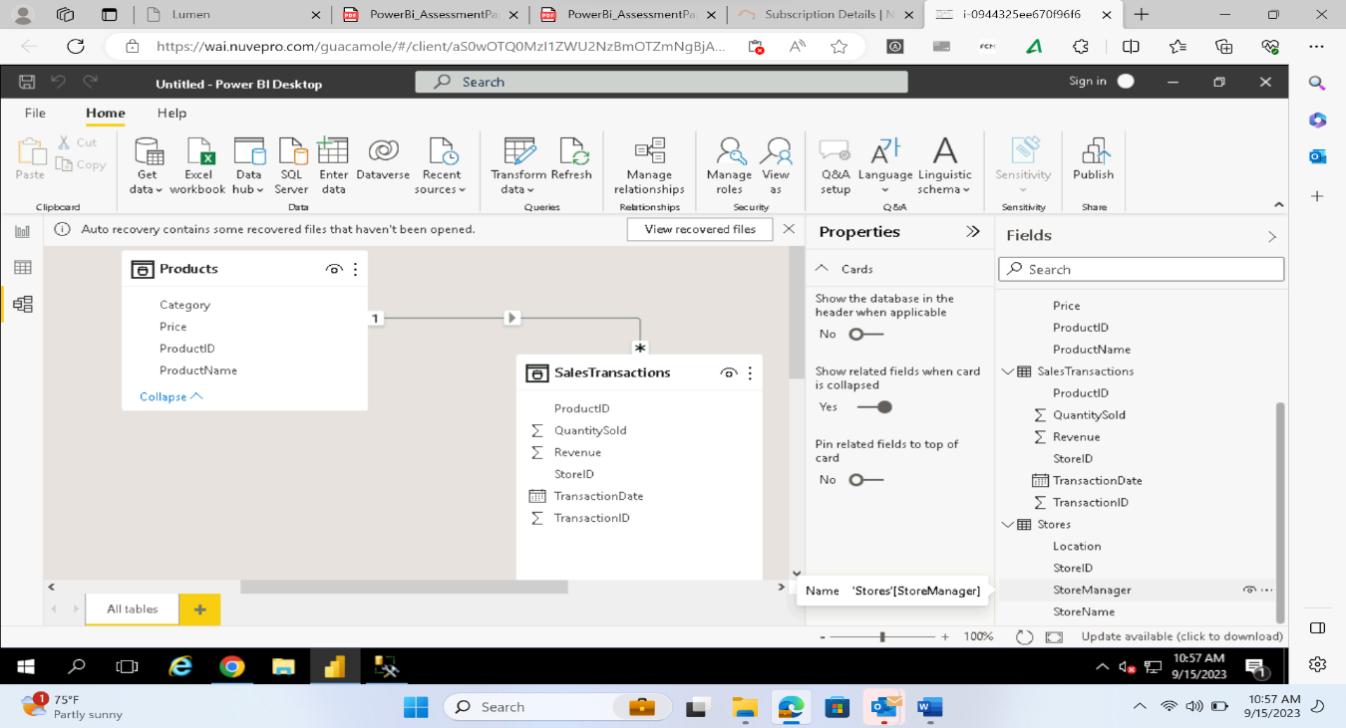

Many to One Relationship exist between Sales Transactions, Products table and Stores.

One to Many Relationship exist between Products, Stores and Sales Transactions.

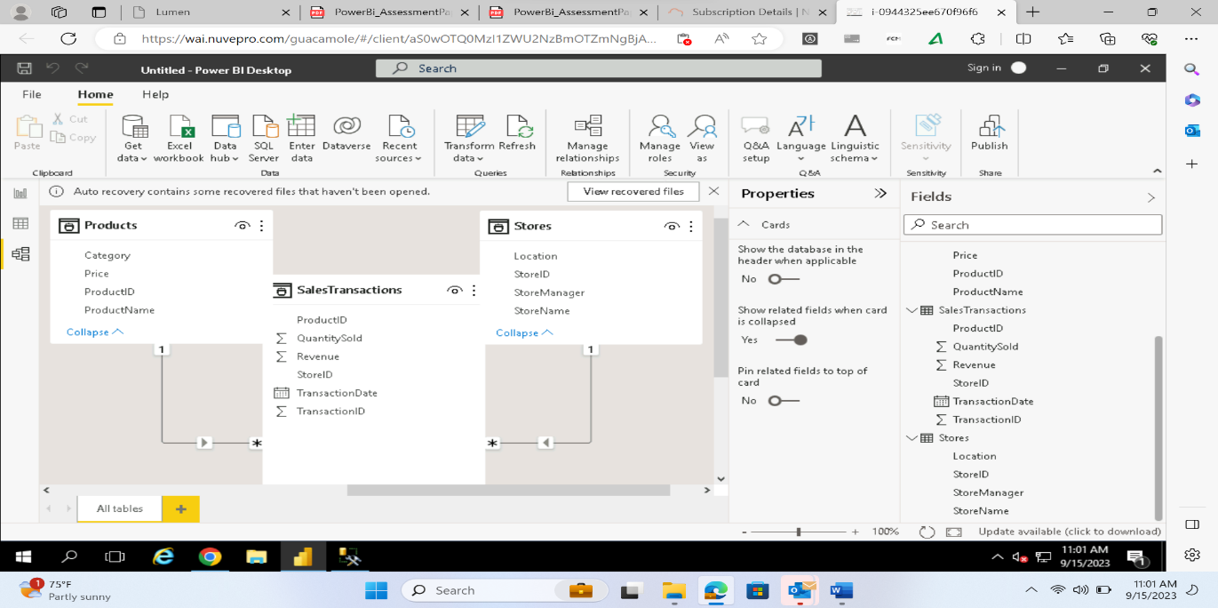

How is sales revenue distributed among different store managers

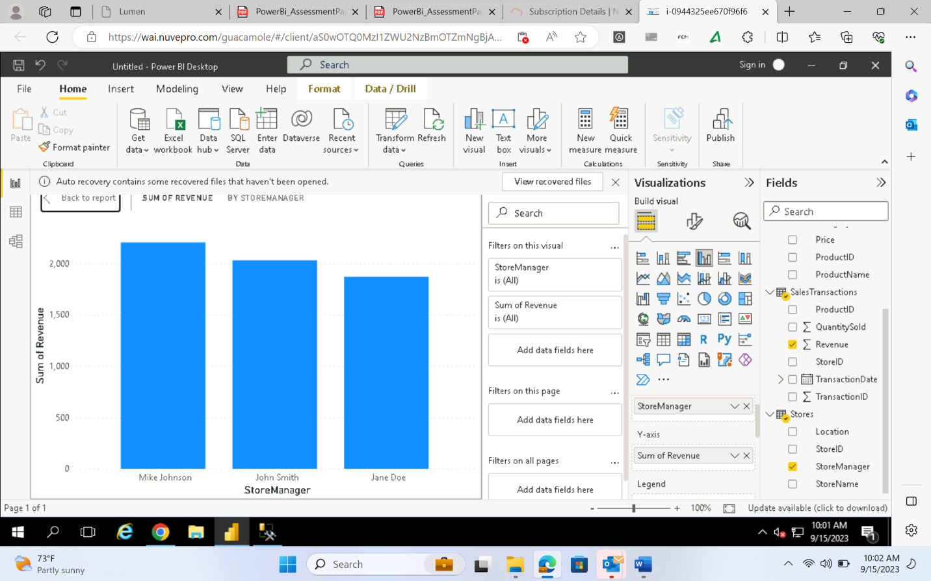

average price of products in each category

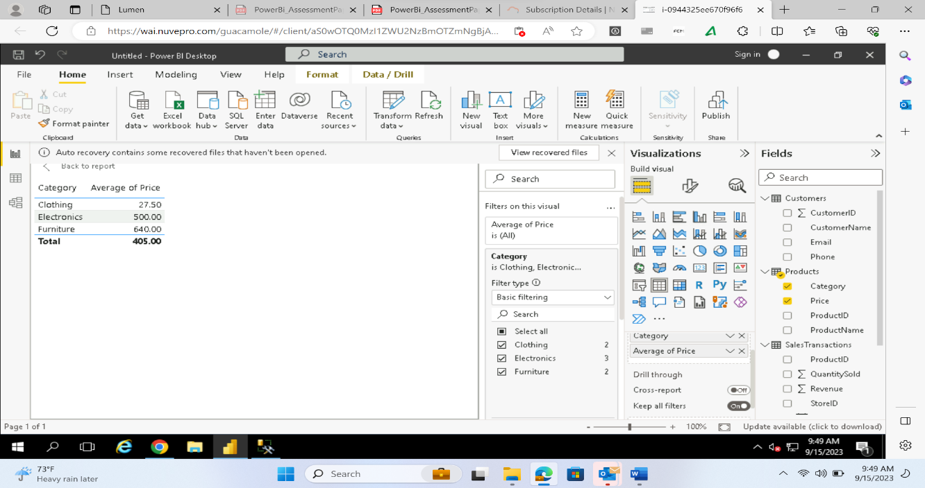

OR

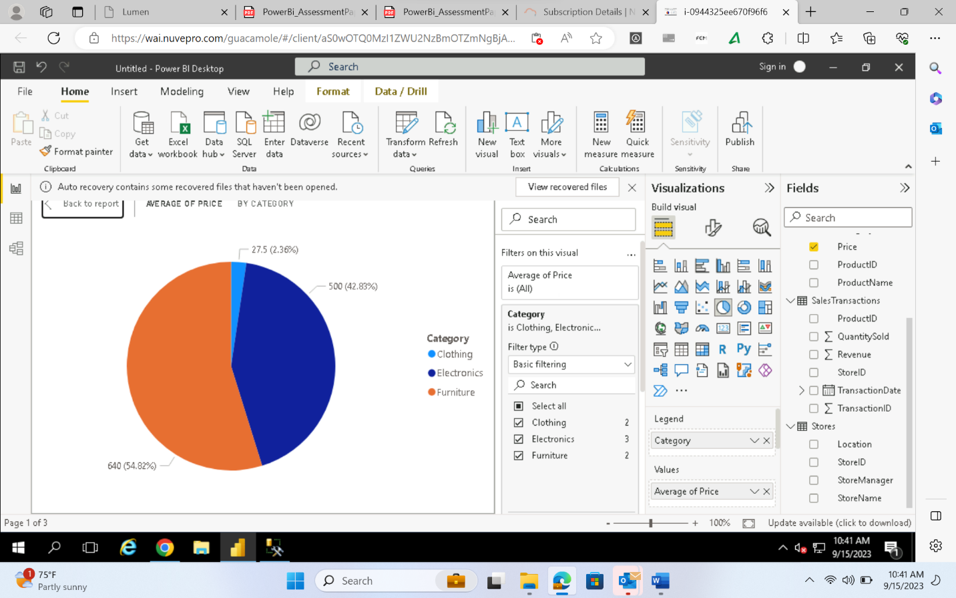

Are there specific days of the week when sales are higher

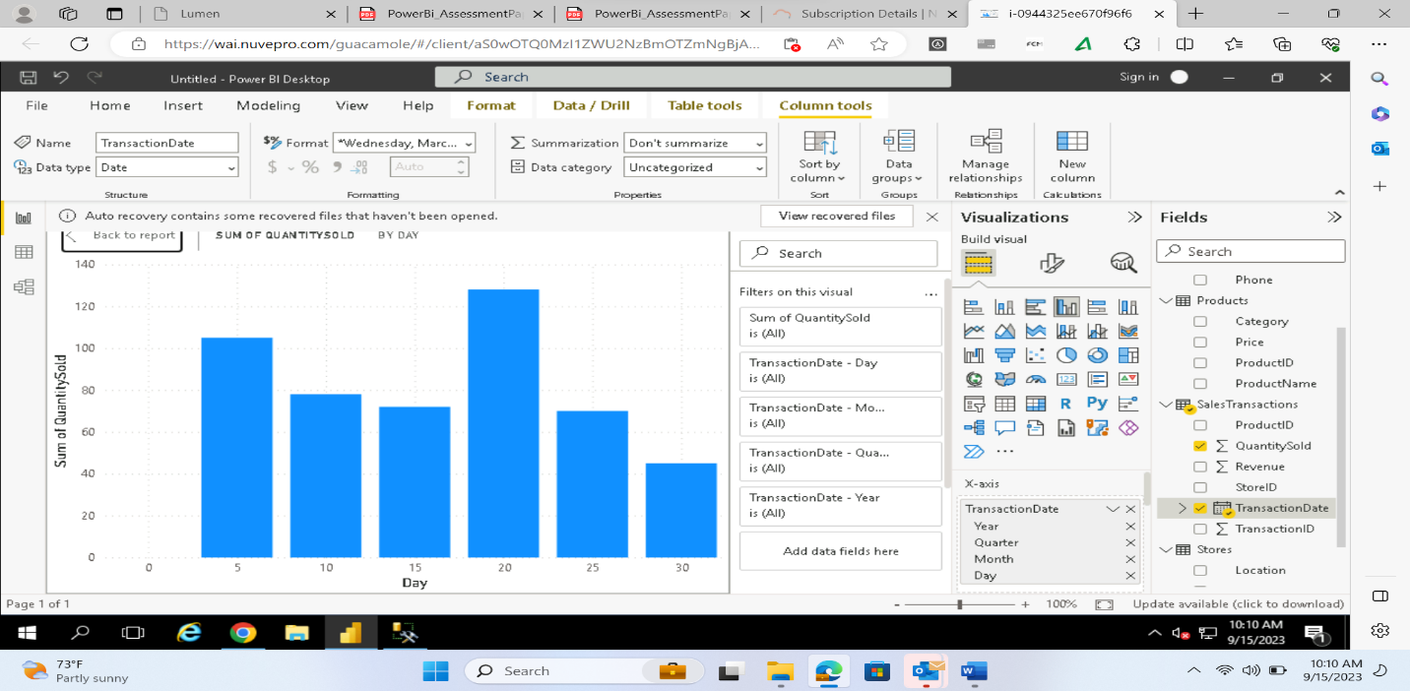

How do sales trends vary by product category on a monthly basis?

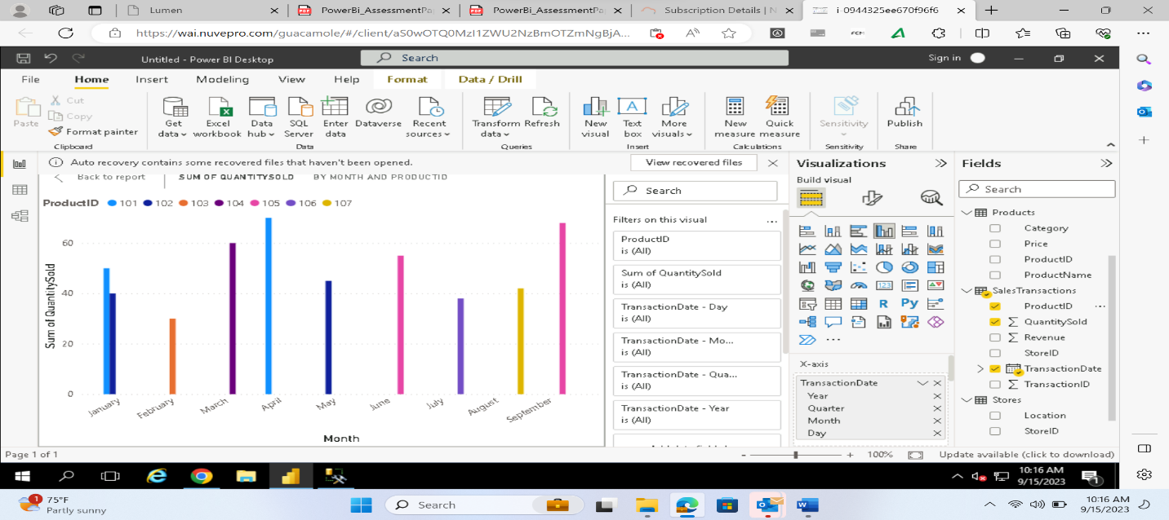

What percentage of products account for % of total sales revenue

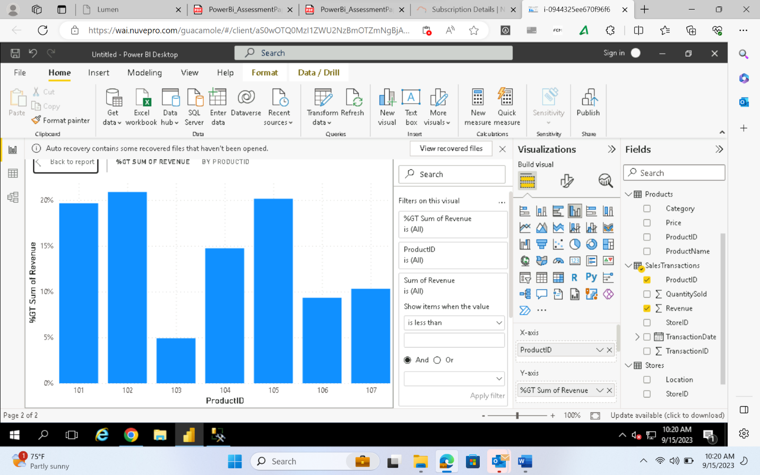

Which product categories perform best at each store location

We can see from the above visualization that electronics in newyork performs best at each store.

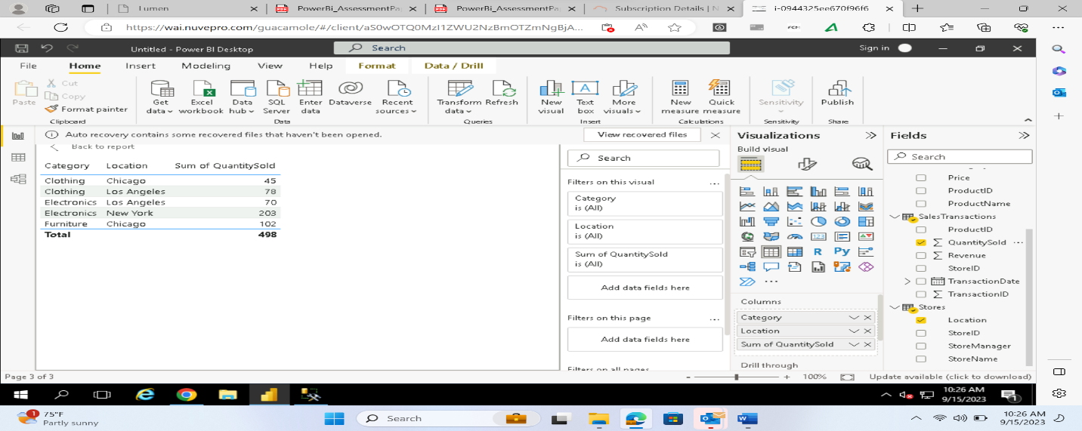

Are there any seasonal patterns or trends in sales for specific products or categories

IF WE SEE SALES TRENDS FOR SPECIFIC PRODUCTS OR CATEGORIES ON THE BASIS OF MONTH WE CAN SEE THAT SALES OF PRODUCT IS IN INCREASING ,decreasing or vice-versa manner.

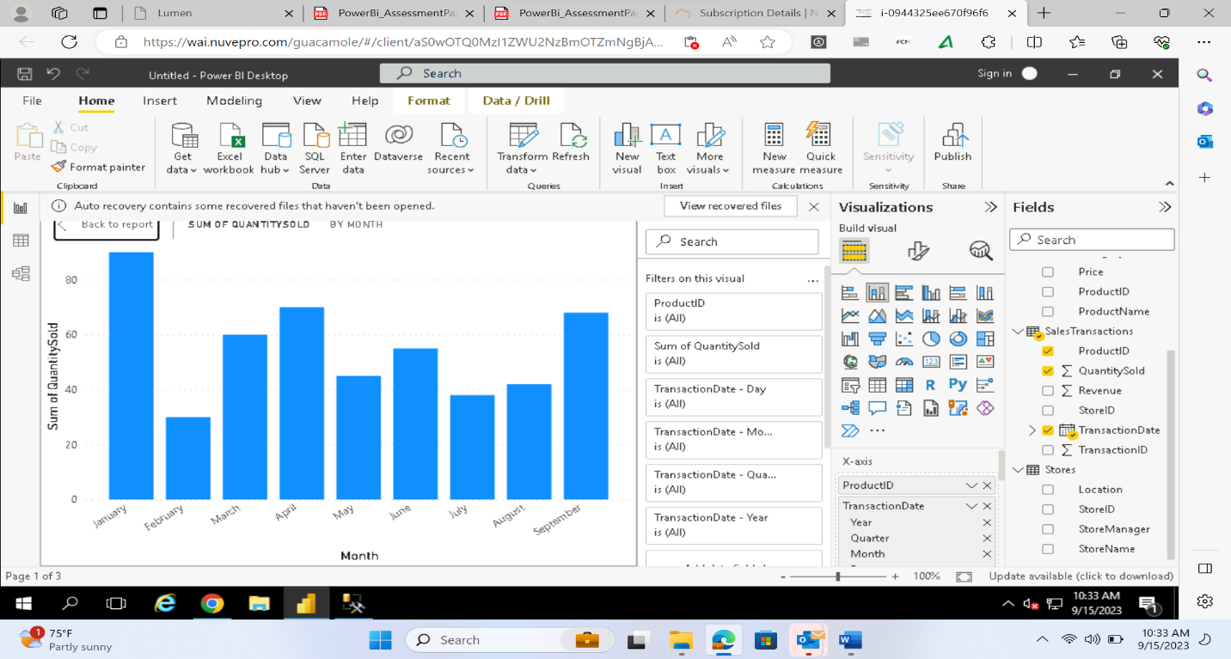

On Quarterly basis sales of product is decreasing .

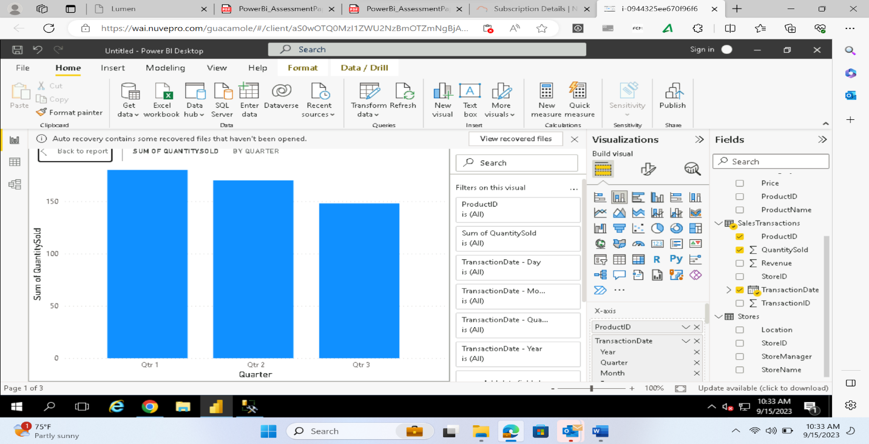

On the basis of month sales is increasing .

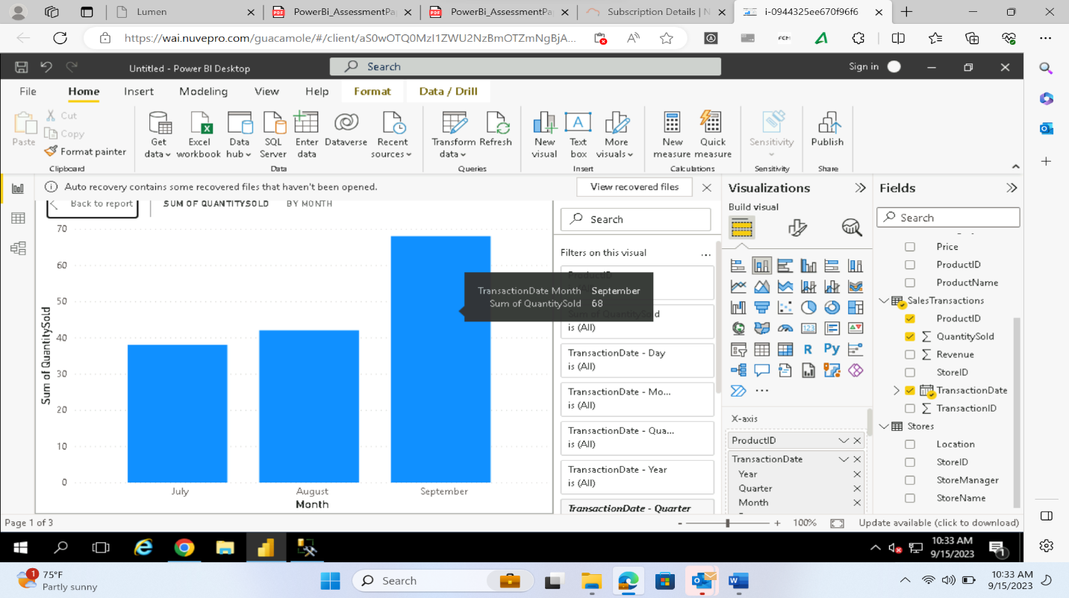

Requirement 5: Data Insights and Recommendations –

Analyze Patterns:

* IF WE SEE SALES TRENDS FOR SPECIFIC PRODUCTS OR CATEGORIES ON THE BASIS OF MONTH WE CAN SEE THAT SALES OF PRODUCT IS IN INCREASING , decreasing or vice-versa manner.
* On Quarterly basis sales of product is decreasing .
* On the basis of month sales is increasing .

